**Industry-Level Forecasting and Volatility Analysis**

*Assessing Retail Sector Stability and Forecast Risk for Nationwide Apparel Retailer Inc.*

**Author:** James Gifford

**Date:** October 2025

**Tools Used:** PostgreSQL | Excel (Forecasting, Scenario Modeling, Volatility Index Construction)

**Data Source:** U.S. Census Monthly Retail Trade Survey (MRTS) via FRED

Contents

1. Executive Summary 3

2. Background and Business Context 3

3. Data and Methodology 4

3.1 Data Sources and Coverage 4

3.2 Data Preparation and Workflow 5

3.3 Methodological Approach 6

4. Forecast Accuracy Evaluation 7

5. Forecast Results and Interpretation 8

5.1 Interpretation of Forecast Results 8

6. Volatility Index Analysis 11

6.1 12-Month vs. 3-Month Volatility 11

7. Scenario Analysis - Supply and Demand Constraints 13

7.1 Methodology 14

7.2 Results and Example 14

7.3 Interpretation and Business Value 15

8. Business Insights and Recommendations 16

8.1 Clothing & Accessories 16

8.2 Food Service 17

8.3 Department Stores 17

8.4 Total Retail & Food Service (Aggregate) 18

8.5 Strategic Takeaway 18

9. Limitations and Next Steps 19

9.1 Limitations 19

9.2 Next Steps 19

10. Conclusion 20

Appendix 22

1. Executive Summary

This report analyzes U.S. retail and food service sales trends, with a focus on understanding volatility, forecast accuracy, and demand risk in the Clothing & Accessories sector. The study is conducted from the perspective of Nationwide Apparel Retailer Inc., a large apparel company operating both physical stores and e-commerce channels. Using seasonally adjusted data from the U.S. Census Monthly Retail Trade Survey, the analysis examines how different retail categories responded to major disruptions, most notably the COVID-19 pandemic, and how **smoothed and scenario-based forecasting** can improve planning under uncertainty.

**Key Findings:**

* Clothing & Accessories proved highly vulnerable during COVID-19, experiencing sharp declines followed by rapid rebounds. However, smoothing techniques restored forecast stability and narrowed confidence intervals.
* Food Service remains the most historically volatile sector, exhibiting record-breaking drops during the pandemic and slower normalization afterward.
* Department Stores demonstrated resilience and relative stability, even registering sales spikes as consumers reallocated spending from closed specialty stores.
* **Volatility indices quantitatively revealed** both short-term disruptions and the longer-term recovery timeline, highlighting where uncertainty persisted.
* **Scenario modeling** showed that even modest supply or demand shocks (5-10 %) could materially affect forecasted revenue, underscoring the need for scenario-based planning.

**Business Takeaway:**

Improved forecasting and volatility analysis provide Nationwide Apparel Retailer Inc. with a stronger foundation for data-informed decision-making. These tools enhance demand visibility and support more effective inventory management, marketing allocation, and channel strategy, **enabling the company to respond confidently to changing market conditions and strengthen resilience in future disruptions.**

2. Background and Business Context

The retail landscape in the United States has experienced **extreme volatility** in recent years, shaped by pandemic disruptions, evolving consumer preferences, and global supply chain instability. For Nationwide Apparel Retailer Inc., understanding how these forces interact is essential to maintaining profitability and ensuring operational resilience.

The clothing sector is uniquely exposed to fluctuations in discretionary spending and global manufacturing dependencies. Unlike essential categories such as groceries or fuel, apparel demand is highly sensitive to external conditions, ranging from macroeconomic cycles and consumer confidence to import delays and shifts toward online channels.

**U.S. Census seasonally adjusted data** is used throughout this analysis to remove predictable calendar effects (for example, holidays and back-to-school peaks) and isolate true underlying demand trends. This allows the company to focus on structural changes in spending behavior rather than routine seasonal variations.

From a business standpoint, the company’s central concerns include:

* Improving demand visibility to reduce the risk of stockouts or overproduction.
* Managing inventory and logistics under uncertain supply conditions.
* Identifying emerging demand cycles that do not align with fixed retail seasons.
* **Enhancing forecast reliability and volatility monitoring** to better align purchasing, marketing, and staffing decisions with real-time market dynamics.

Through this lens, the subsequent analysis explores both the historical behavior of retail sectors and the predictive modeling of future conditions, connecting statistical insights directly to actionable business planning. **The next section details the data sources, preparation steps, and analytical methods used to develop these insights.**

3. Data and Methodology

3.1 Data Sources and Coverage

This analysis draws on seasonally adjusted monthly time series from the U.S. Census Bureau’s Monthly Retail Trade Survey (MRTS), obtained through the Federal Reserve Economic Data (FRED) portal. The dataset spans January 1992 through August 2025, providing more than three decades of retail and food-service performance for trend and volatility assessment. For analyses requiring full-year coverage or rolling calculations, the usable sample was narrowed to January 1993 through December 2024 to maintain consistency and avoid partial-year bias.

Four MRTS series were used:

RSAFS - **Total Retail & Food Services** captures aggregate monthly sales across all retail industries (NAICS 44-45) and food services (NAICS 722), including both brick-and-mortar and e-commerce channels.

RSCCAS- **Clothing & Accessories Stores** measures apparel, shoe, jewelry, luggage, and leather-goods retailers (NAICS 448), representing the focal segment for this report.

RSDBS- **Department Stores** represents traditional multi-category stores (NAICS 4522), excluding warehouse clubs and supercenters.

RSEAS- **Food Services & Drinking Places** includes restaurants, cafeterias, and bars (NAICS 722) but excludes grocery and convenience stores in NAICS 445.

Clothing, Department Stores, and Food Services are subcomponents of the Total Retail & Food Services series, chosen for their direct relevance to discretionary spending and for providing contrasting perspectives on consumer behavior. This structure allows comparisons between the company’s core apparel market and other retail categories that respond differently to macroeconomic shocks.

To minimize distortion from pandemic outliers, each series was supplemented with a **COVID-Smoothed variant**. Values for March through August 2020 were imputed as the average of the same months in 2019 and 2021. This retained realistic seasonality and long-term trend continuity while reducing volatility from the shutdown-and-reopening cycle, producing cleaner input data for forecasting and volatility analysis.

3.2 Data Preparation and Workflow

The workflow followed a two-stage process that combined SQL-based data preparation with Excel-based modeling and visualization.

First, the raw FRED CSV files were imported into a PostgreSQL database and queried using VS Code. Each dataset was aligned by observation date and merged into a unified table containing all four retail categories. Within SQL, additional fields were created for month-over-month (MoM) and year-over-year (YoY) percentage changes, providing standardized measures of short-term and annual growth. The resulting cleaned dataset was then exported to Excel for further analysis.

While the entire process could have been completed directly in Excel, using SQL added structure and transparency to the workflow. The database environment ensured reproducibility, precise data alignment, and efficient calculation, while Excel offered a flexible platform for modeling, visualization, and scenario testing.

3.3 Methodological Approach

Once in Excel, the analytical work proceeded through four main pillars-forecasting, accuracy evaluation, volatility measurement, and scenario modeling-each designed to provide a different lens on sales stability and risk.

Forecasting was conducted with Excel’s *Forecast Sheet* feature, which applies an exponential smoothing (ETS) algorithm to project future sales through December 2026 and automatically generates 95 percent confidence intervals. Forecasts were produced for both the Original and COVID-Smoothed datasets, allowing direct comparison of their stability.

Forecast accuracy was then evaluated using three standard error metrics: Mean Absolute Percentage Error (MAPE), Root Mean Square Error (RMSE), and Mean Absolute Deviation (MAD). These measures quantify proportional, squared, and absolute forecast errors, respectively, and together provide a balanced assessment of model reliability.

To capture instability in sales patterns, a **Volatility Index** was developed from the rolling standard deviation of monthly percent changes, normalized to the 2010-2019 baseline (index = 1.0). Two window lengths were calculated: a 12-month index, showing persistent disruptions and long-term uncertainty, and a 3-month index, highlighting short-term spikes and rapid recoveries. The index was further transformed using a log₂ scale so that deviations could be read as multiples of baseline (0 = baseline, +1 = 2×, -1 = 0.5×, +2 = 4×). This made extreme events such as COVID-19 easier to interpret on a common scale.

Finally, a **Supply/Demand Shock Calculator** was constructed in Excel to model uniform percentage reductions (0 to 35 percent, in 5-percent increments) to forecasted sales volumes. These scenarios simulate disruptions such as tariffs, vendor allocation cuts, or logistics bottlenecks and automatically recompute baseline totals, shock-adjusted forecasts, and upper- and lower-bound confidence intervals.

Together, these methods integrate statistical rigor with business interpretability-linking SQL-based data preparation, Excel-based forecasting, and scenario testing into a cohesive analytical framework.

4. Forecast Accuracy Evaluation

Forecast performance was assessed using the MAPE, RMSE, and MAD metrics described above, comparing the Original and COVID-Smoothed versions for each category. These metrics reveal how smoothing affected forecast precision and stability under differing volatility conditions.



***Table 4.1:*** *Forecast accuracy results for each retail category under Original and COVID-Smoothed models. Lower error values indicate improved stability and reliability in smoothed forecasts, especially for Clothing & Accessories.*

* **Total Retail & Food Services:** At the aggregate level, forecasts remained highly stable, with MAPE at 0.58%. The smoothed data produced slightly tighter confidence intervals, reducing minor fluctuations without altering the underlying trend
* **Clothing & Accessories:** Accuracy improved markedly. The Original series had a MAPE near 5%, reflecting the extreme pandemic-era swings, but smoothing reduced this to 2.85%. Confidence intervals narrowed substantially, signaling greater reliability for forward-looking planning and inventory control.
* **Department Stores:** Forecasts already exhibited strong forecast precision, with MAPE at 0.27%. Smoothing produced little change, confirming the category’s relative resilience and low volatility even during broader market shocks.
* **Food Services:** Forecastsshowed exceptionally low forecast error (about 0.01%) but the confidence intervals widened sharply during 2020, when volatility spiked more than tenfold. Smoothing compressed those intervals but did not remove the sector’s inherent unpredictability.

Overall, the smoothed datasets produced more stable and realistic forecasts across all categories, particularly in segments heavily distorted by temporary shutdowns. By reducing the influence of outliers, the smoothed approach enhances the reliability of demand projections and mitigates the risk of over- or under-stocking decisions driven by anomalous data.

While the numerical error metrics show the greatest improvement in the *Clothing & Accessories* category, they capture only part of the benefit of smoothing. In the next section, we examine the forecast outputs and their confidence bounds, where the impact of smoothing becomes much clearer. The smoothed models produce visibly tighter uncertainty bands and a more stable baseline trajectory, demonstrating why constructing these adjusted versions is valuable for understanding true underlying trends.

5. Forecast Results and Interpretation

The forecasts reveal distinct patterns in how different retail categories responded to the COVID-19 disruptions and how smoothing affected model stability. Building on the numerical accuracy results from Section 4, this section visualizes the forecast outputs and confidence intervals to evaluate how smoothing influenced volatility and forecast reliability across sectors.

5.1 Interpretation of Forecast Results

The impact of COVID-19 disruptions is visible across categories, but the effects differ sharply by industry.

**Total Retail & Food Service:** The total retail series provides a broad benchmark for overall market behavior. While it exhibits less volatility than Clothing & Accessories, it is not as stable as Department Stores. The COVID-19 disruption remains clearly visible in the Original data, where confidence intervals widened and short-term noise increased. When the COVID months are smoothed, the overall trajectory remains intact, but the intervals narrow considerably, producing a steadier and more reliable forecast baseline.

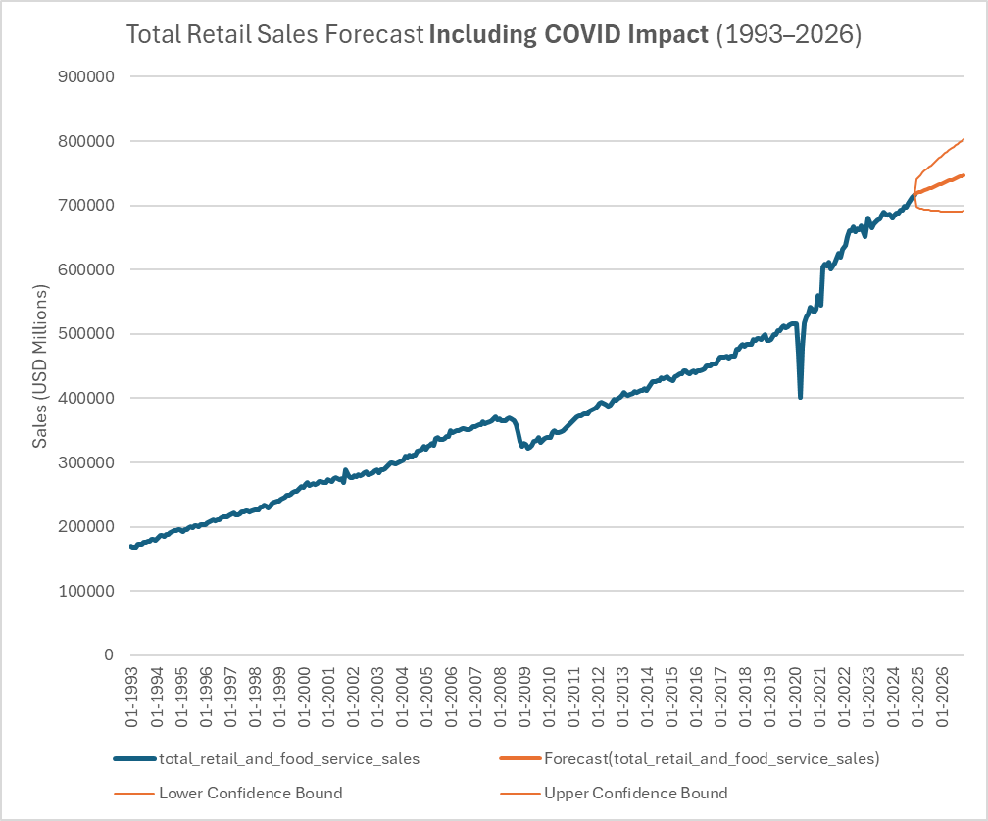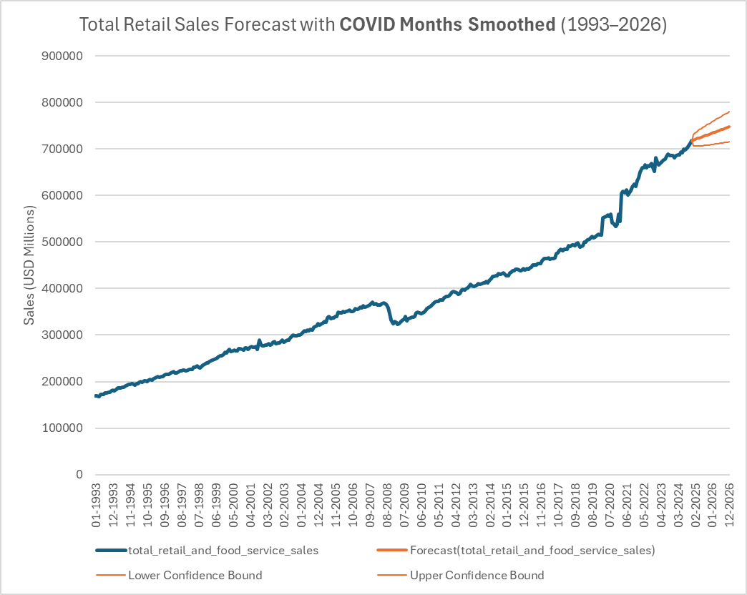

***Figure 5.1:*** *Total Retail & Food Service forecasts (1993-2026), Original vs COVID-Smoothed versions.*

**Clothing & Accessories** sales historically showed moderate volatility-more variable than Total Retail or Department Stores, though far less than Food Service. The sector was disproportionately affected during the pandemic because stores were classified as non-essential and faced prolonged shutdowns. This created a sharp collapse in sales and greatly widened the confidence intervals in the Original forecasts. When the COVID months are smoothed, Clothing returns to a more stable trajectory with narrower bounds, improving forecast reliability.

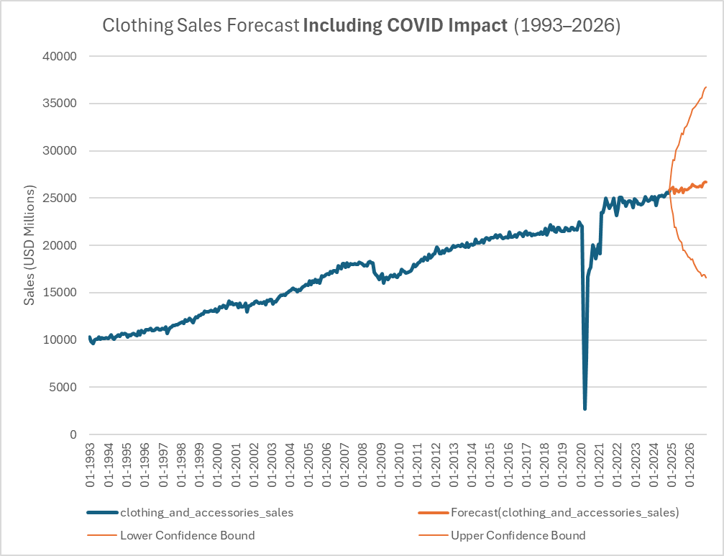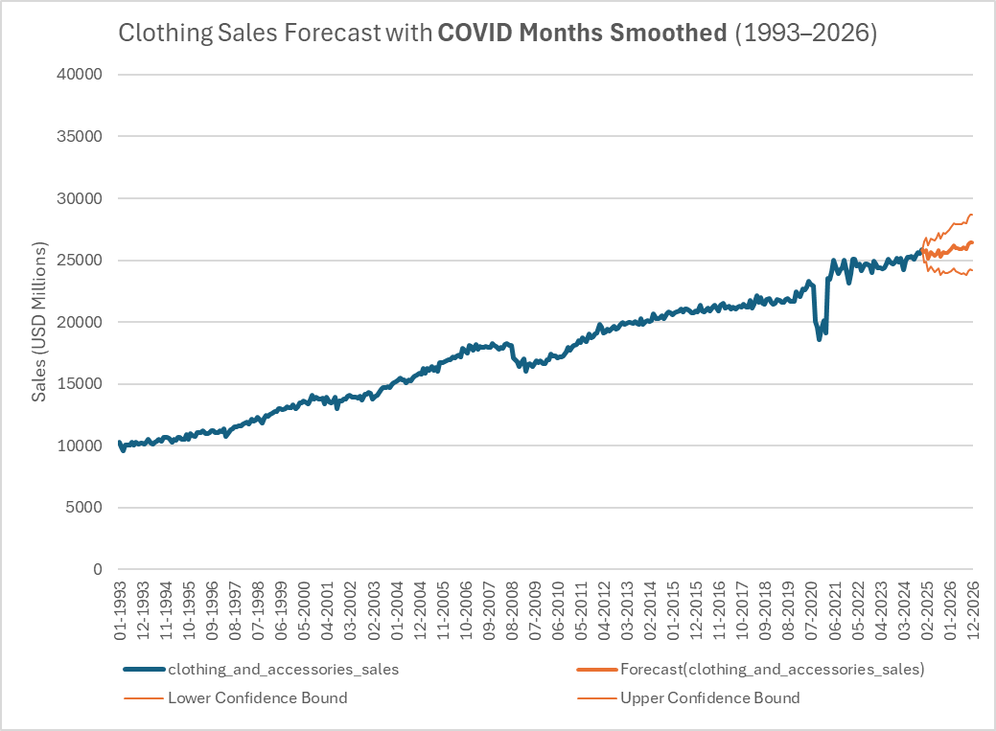

***Figure 5.2:*** *Clothing & Accessories Forecasts - Original vs. COVID-Smoothed*

**Department Store** sales followed the opposite pattern. Rather than collapsing, many stores remained open or captured displaced demand from closed specialty retailers, leading to sales spikes during the pandemic. As a result, the overall forecast trajectory is similar between the Original and Smoothed versions, but the smoothed model tightens the confidence intervals substantially, closing much of the gap around the baseline.

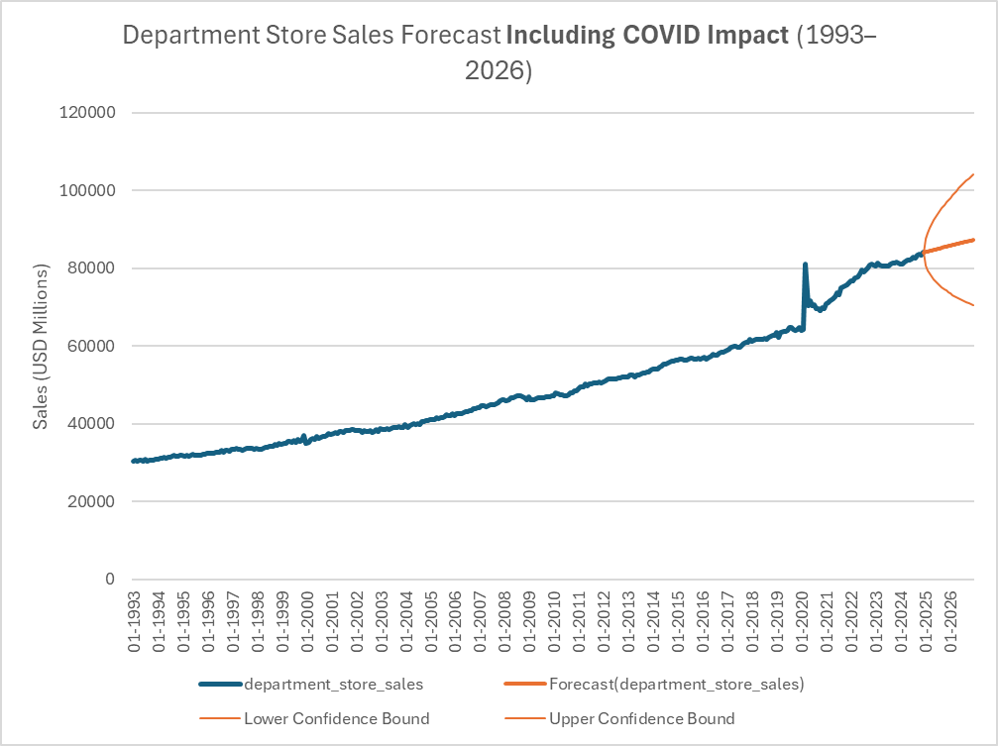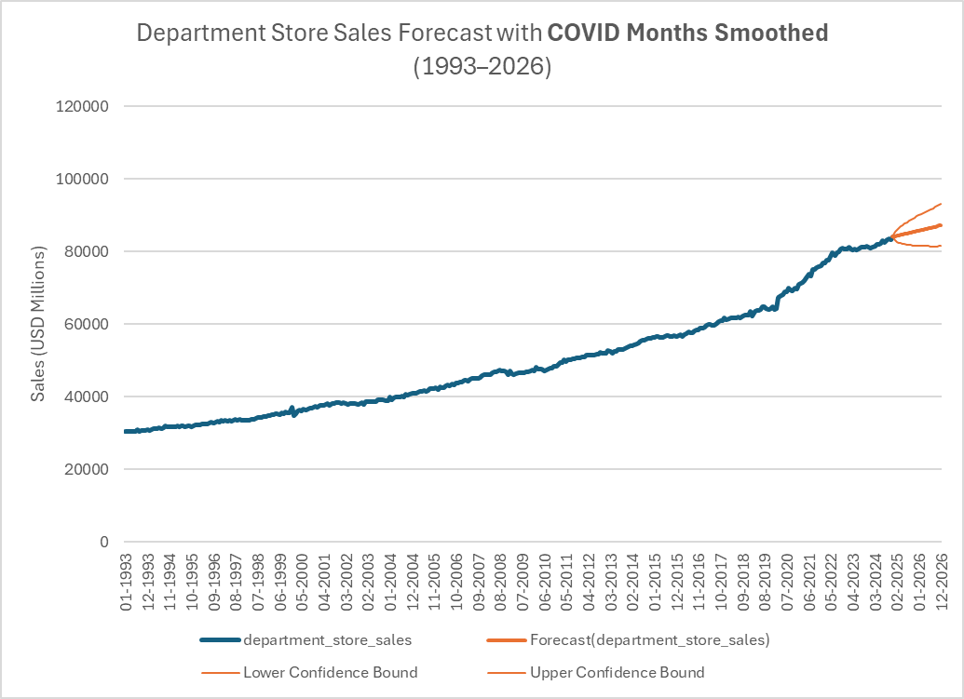

***Figure 5.3:*** *Department Store Forecasts - Original vs. COVID-Smoothed*

**Food Service:** This category has long exhibited higher inherent volatility due to its sensitivity to external shocks and consumer behavior shifts. During the pandemic, it experienced one of the steepest collapses on record, followed by a rapid but incomplete rebound that left sales fluctuating below pre-pandemic peaks. The Original forecast reflects these turbulent swings with wide confidence intervals, while the COVID-Smoothed version dampens the extremes, clarifying the underlying trend and reducing forecast distortion without fully eliminating residual instability.

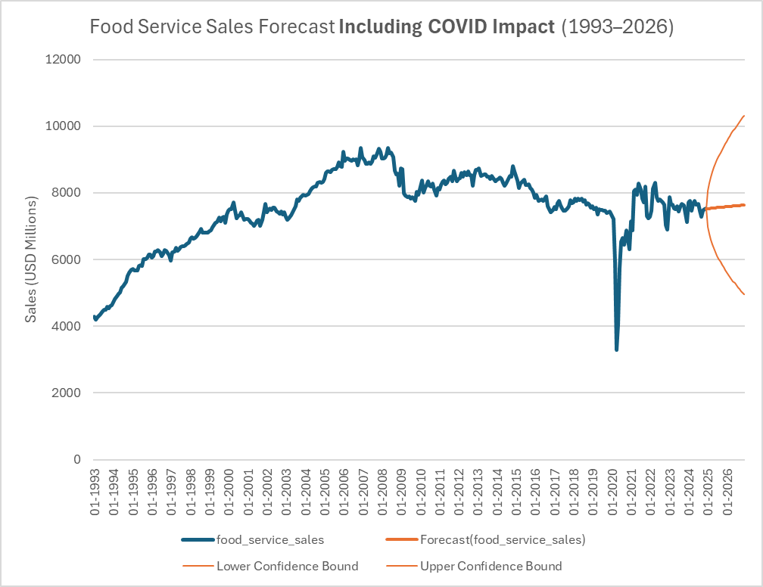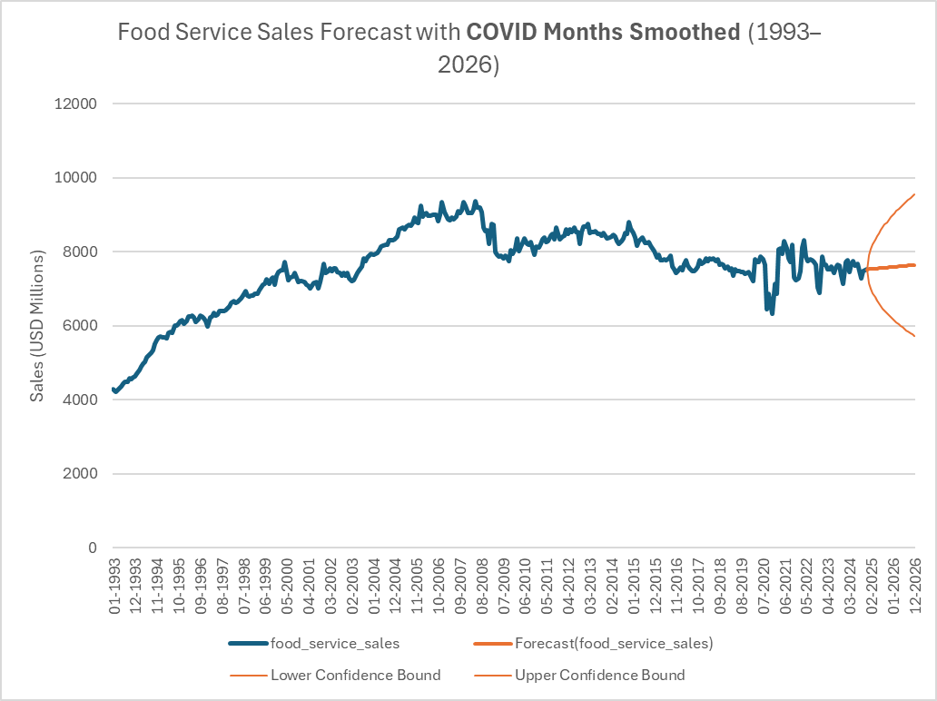

***Figure 5.4:*** *Food Service Forecasts - Original vs. COVID-Smoothed*

**Key Takeaway:**

COVID shocks affected retail categories unevenly. Clothing shows the clearest benefit from smoothing, with extreme disruptions normalized into a stable trajectory. Department Stores proved the most resilient, maintaining consistent performance throughout the period. Food Service illustrates the most erratic behavior, with an abrupt collapse followed by partial recovery, highlighting its exposure to external shocks. The Total Retail & Food Service series demonstrates how smoothing clarifies overall market trends by filtering out short-term volatility and emphasizing the underlying growth pattern.

6. Volatility Index Analysis

Building on the forecast results from Section 5, this section examines volatility patterns across retail categories to quantify the scale and duration of disruptions more precisely.

To measure instability more directly, rolling volatility indices were constructed using both 12-month and 3-month windows of month-over-month percentage change. Each series was normalized to its 2010-2019 average volatility (index = 1.0) to establish a long-term baseline for comparison.

For both versions, a linear and log₂ visualization was created:

* **Linear:** Values above 1.0 indicate higher-than-normal volatility, while values below 1.0 represent calmer conditions.
* **Log:** A log₂ transformation was applied for interpretability, where 0 = baseline, +1 = 2× baseline, -1 = 0.5× baseline, and +2 = 4× baseline. This scaling allows for meaningful comparison of extreme volatility events such as the pandemic.

The analysis began with a 12-month rolling index to evaluate long-term volatility patterns, but this measure kept pandemic-era extremes visible well after conditions stabilized because of its extended rolling window. To better represent the abrupt, short-lived nature of the COVID-19 shock and recovery, a complementary 3-month version was developed. Each provides distinct benefits: the 12-month index highlights persistent disruptions and lingering forecast uncertainty, while the 3-month index isolates short-term volatility spikes and the speed of normalization. Together, they offer a more complete picture of volatility dynamics across different time horizons.

6.1 12-Month vs. 3-Month Volatility

The 12-month volatility index (Figure 6.1) captures the persistence of market instability following major disruptions. Volatility rose sharply in early 2020 and remained elevated through much of 2021, reflecting how pandemic-era swings continued to influence the rolling average long after sales had begun stabilizing. Clothing & Accessories shows the highest and longest-lasting elevation, followed by Department Stores and Food Service. In contrast, Total Retail & Food Service remained comparatively steady at the aggregate level, as broader diversification muted category-specific extremes.

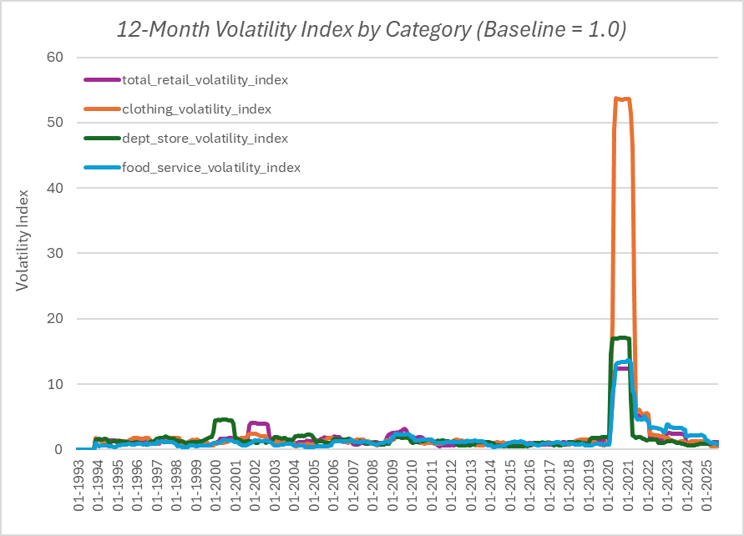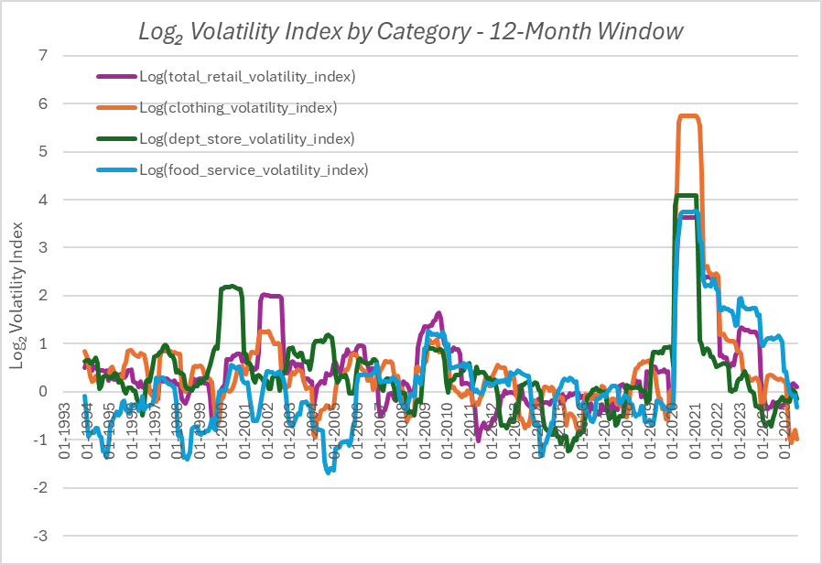

***Figure 6.1:*** *12-Month Volatility Index - Linear Scale (Left), Log₂ (Right)*

The 3-month index (Figure 6.2) provides a sharper, more immediate view of volatility dynamics. It reveals the abrupt collapse and rebound cycle during April-May 2020, when Clothing & Accessories and Food Service sales plunged under mandatory shutdowns and then surged once restrictions lifted. These spikes represent the *whiplash effect* of rapid demand contraction followed by equally rapid normalization. Clothing peaked at over 100× its baseline volatility, Department Stores and Food Service near 40× and 30× respectively, while Total Retail & Food Service peaked around 12× baseline in early 2021.

By late 2020, volatility in most categories had fallen below 10× baseline, signaling that short-term instability subsided within a few months even though the 12-month measure remained inflated due to its lagged window. The log₂ chart, while more variable in appearance, helps contextualize the relative scale of these swings across categories, illustrating how volatility levels converged toward baseline by 2021 even amid small fluctuations.

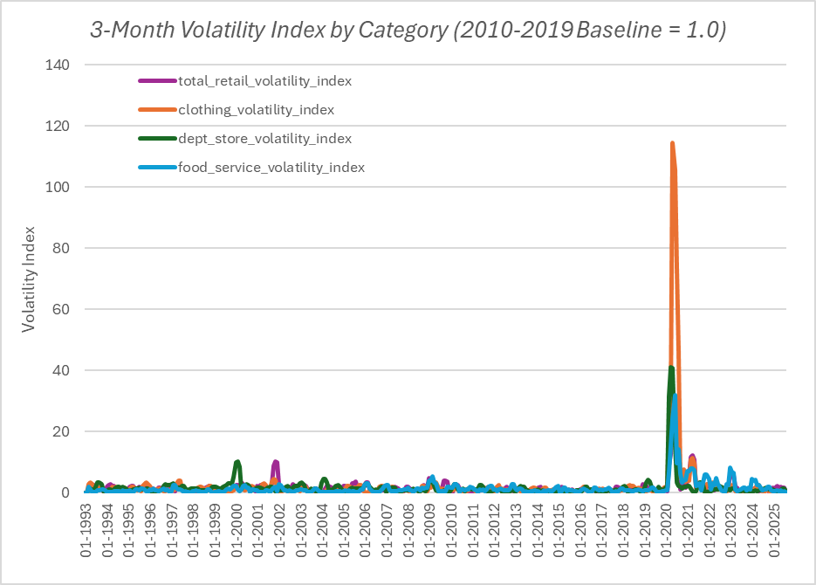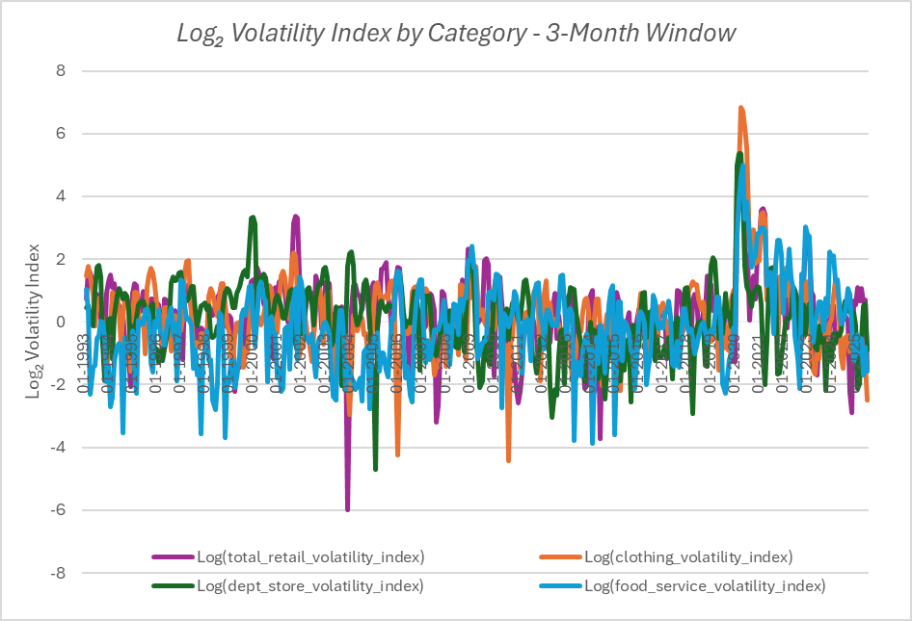

***Figure 6.2:*** *3-Month Volatility Index - Linear Scale (Left), Log₂ (Right)*

These volatility spikes align closely with the widened confidence intervals seen in the Original forecasts, confirming that short-term volatility, rather than model error, was the primary source of forecast uncertainty during the pandemic.

While the 3-month index shows the immediate shock and fast stabilization, the 12-month view underscores how those extreme months prolonged statistical uncertainty in forecasts well into 2021. The combination of both measures clarifies how short-term shocks translate into long-term forecasting risk.

**Key Takeaway:**

The 12-month index emphasizes the lingering uncertainty embedded in long-term forecasts, while the 3-month index captures the timing and intensity of short-term shocks. During COVID-19, volatility surged across all categories but dissipated rapidly once markets reopened, though its statistical effects persisted far longer in rolling models. Together, the two measures distinguish between *temporary disruption sensitivity* and *forecast-level uncertainty*, providing a more complete picture of retail sector resilience and risk exposure.

7. Scenario Analysis - Supply and Demand Constraints

To assess how sensitive forecasted sales are to external disruptions, a Scenario Calculator was developed to simulate the effects of varying supply or demand shocks across the forecast horizon. This tool allows users to apply a uniform reduction factor ranging from **0 % to 35 %** (in 5 % increments) to forecasted sales volumes, modeling different levels of constraint severity. The objective is to quantify how external pressures, such as tariffs, inbound logistics bottlenecks, vendor allocation cuts, or regulatory compliance holds, could alter expected revenues for each retail category.

7.1 Methodology

The calculator applies the selected reduction percentage to each month of the forecast period (September 2025 through December 2026) and automatically recalculates total sales under three perspectives.

Each output metric builds upon the baseline forecast, illustrating how uncertainty expands or contracts under constrained conditions:

* **Shock-Adjusted Forecast Total:** the resulting total after applying the chosen reduction.
* **Downside Impact:** the lower bound of the 95 % confidence interval after the reduction, compared to the baseline total. This represents the plausible worst-case scenario.
* **Upside Impact:** the upper bound of the 95 % confidence interval after the reduction, compared to the baseline total. This reflects the optimistic scenario if conditions improve despite the constraint.

All values are derived from seasonally adjusted data and are expressed in USD millions. Confidence intervals represent a 95 % range from Excel’s forecast model, indicating the expected span in which true sales may fall under uncertainty.



***Table 7.1:*** *Scenario Calculator: Summary Table (currently set at 5% Supply/Demand Reduction)*

7.2 Results and Example

Using the Clothing & Accessories category as an example, a 5% reduction was selected to demonstrate the model’s behavior.

*Under this scenario:*

* The shock-adjusted forecast is roughly $590,000 lower than the baseline, representing the expected shortfall under a 5 % constraint.
* The downside impact extends to about -1,000,000, indicating potential losses if conditions worsen.
* The upside impact is approximately -181,000, suggesting that even under favorable assumptions, the constraint prevents sales from fully rebounding to baseline.

These results reveal how forecast sensitivity narrows under the COVID-Smoothed model, which features tighter confidence intervals and improved forecast stability compared with the Original version. This stability translates into more reliable downside estimates and clearer planning guidance.

The table below presents monthly forecasted sales and confidence bounds for each model version in the **Clothing & Accessories** category. Full monthly results for all categories are provided in the **Appendix (Table A.1)**.



***Table 7.2:*** *Scenario Calculator - Monthly Impact Table: Clothing & Accessories (5% Supply/Demand Reduction) Displays baseline, shock-adjusted, and 95% confidence bounds under the 5% constraint scenario.*

7.3 Interpretation and Business Value

The scenario framework enables apparel retailers to test a range of plausible disruptions and evaluate the resulting financial impact in real time. Lower shock levels (5-10 %) reflect moderate supply-chain or demand constraints such as vendor delays or minor inventory shortages, while higher levels (20-35 %) simulate severe disruptions such as pandemic-era lockdowns, port closures, or major consumer pullbacks.

By visualizing how these scenarios compress the baseline and confidence ranges, decision-makers can quantify risk exposure and design appropriate mitigation strategies.

For Nationwide Apparel Retailer Inc., this analysis highlights how even moderate supply constraints can meaningfully reduce total revenue potential for the Clothing & Accessories category, a segment already prone to elevated volatility and slower stabilization after shocks. The Scenario Calculator provides a dynamic framework for stress-testing sales forecasts and refining contingency plans across production, sourcing, and promotional strategies.

Ultimately, this scenario-modeling framework equips Nationwide Apparel Retailer Inc. to quantify risk exposure, anticipate financial impacts, and plan targeted responses to supply- or demand-side disruptions with greater confidence.

8. Business Insights and Recommendations

The combined forecasting, volatility, and scenario analyses provide a comprehensive view of how retail sectors respond to external shocks and how forecast stability varies by category. For Nationwide Apparel Retailer Inc., these insights translate directly into data-driven decisions on inventory management, marketing allocation, and operational risk planning.

8.1 Clothing & Accessories

Clothing remains the most volatile category, characterized by sharp demand collapses and rapid rebounds during market disruptions. Even after applying smoothing adjustments, the category’s confidence intervals remain wider than those of other sectors, reflecting persistent uncertainty in consumer behavior and discretionary spending. This volatility underscores the need for flexible, data-responsive planning.

**Recommendation:**

* **Maintain adaptive inventory practices**, emphasizing shorter reorder cycles, diversified sourcing, and contingency stock for fast-moving items.
* **Incorporate real-time demand sensing**, using internal sales trends and external indicators (e.g., search data or digital engagement) to adjust production and promotions dynamically.
* **Align marketing spend with volatility signals**, concentrating investment during recovery phases when pent-up demand accelerates sales, and scaling back during downturns to preserve margins.

These actions position the clothing segment to absorb shocks more effectively while capitalizing quickly on rebounds once stability returns.

8.2 Food Service

Food Service forecasts show low point-estimate error but consistently high volatility, driven by sensitivity to macroeconomic conditions such as health mandates, consumer mobility, and input-cost fluctuations. Because dining activity often shifts early in the economic cycle, volatility in Food Service serves as a leading indicator of broader consumer sentiment, including discretionary categories like apparel.

**Recommendation:**

* **Monitor Food Service sales volatility as an early signal** of upcoming changes in discretionary spending patterns that could affect apparel demand.
* **Integrate mobility and consumer-spending data** into demand forecasts to anticipate slowdowns or rebounds in clothing sales.
* **Use the Scenario Calculator to test exposure** to cascading shocks originating from consumer or supplier behavior in the Food Service sector.

8.3 Department Stores

Department Stores demonstrate exceptional forecast accuracy and resilience, maintaining consistently tight confidence intervals and limited volatility even through economic shocks. This stability reflects both diversified product lines and enduring customer loyalty. Because Department Stores share a customer base and product overlap with the apparel sector, their performance serves as a reliable benchmark for consumer confidence in physical retail environments.

**Recommendation:**

* **Use Department Store sales trends as a confidence gauge** for in-person retail demand and broader discretionary spending.
* **Benchmark Clothing forecasts against Department Store performance** to determine whether volatility stems from apparel-specific factors or industrywide sentiment.
* **Leverage Department Stores as a stable channel partner** during uncertain periods, ensuring baseline sales continuity even when direct apparel demand softens.

8.4 Total Retail & Food Service (Aggregate)

At the aggregate level, smoothing pandemic-era volatility improved trend visibility and reduced the risk of reacting to temporary outliers. The total retail and food service index functions as a macroeconomic barometer, providing context for interpreting category-level deviations and aligning operational decisions with overall market direction.

**Recommendation:**

* **Use aggregate trends for long-term planning**, including budgeting, hiring, and capital allocation across channels.
* **Cross-validate category forecasts** against total retail movements to ensure strategic decisions remain aligned with overall market growth or contraction.
* **Incorporate total-market insights** into strategic discussions to balance short-term apparel volatility with broader retail stability.

This top-down perspective ensures that short-term tactical moves remain grounded in long-term market reality.

8.5 Strategic Takeaway

Together, the forecasting models, volatility indices, and scenario simulations form a cohesive decision-support framework that quantifies uncertainty and translates data into actionable strategy.

* **Volatility metrics** identify where and when instability threatens margins or disrupts demand.
* **Confidence intervals** define realistic planning ranges rather than relying on single-point forecasts.
* **Scenario modeling** stress-tests these assumptions under varying market conditions, helping prioritize mitigation strategies.

For **Nationwide Apparel Retailer Inc.**, this integrated framework transforms statistical findings into business foresight. It enables leadership to anticipate risk, stabilize operations, and deploy resources efficiently across shifting market conditions. By combining technical rigor with operational context, the analysis provides a roadmap for navigating volatility, strengthening resilience, and capturing opportunities faster than competitors.

9. Limitations and Next Steps

While this analysis provides meaningful insight into retail sector dynamics and apparel-specific forecasting, several factors limit the precision and generalizability of its results. These constraints primarily reflect the tradeoffs made to balance methodological rigor with data accessibility and reproducibility.

9.1 Limitations

* **Data granularity:** The analysis relies on publicly available data from the U.S. Census Monthly Retail Trade Survey (FRED aggregates) at the category level. Because SKU-level or store-level data were unavailable, intra-category differences such as variation between apparel subtypes, channels, or regional markets could not be captured. This is a common limitation when using national series for industry benchmarking.
* **Forecast model scope:** Excel’s Forecast Sheet uses an Exponential Triple Smoothing (ETS) algorithm suited for seasonally adjusted data. While appropriate for detecting long-term trends, it cannot fully capture nonlinear or abrupt behavioral shifts, such as those caused by sudden policy changes or consumer sentiment swings during the pandemic.
* **Scenario simplification:** External shocks such as tariffs, supply bottlenecks, or vendor constraints were modeled as uniform percentage reductions applied evenly across all months and categories. This simplification provides a clear, consistent basis for comparison but does not account for the uneven or time-varying effects observed in real-world disruptions. The strength of this design is its transparency, since it isolates the effect of constraint severity without additional model complexity.
* **Temporal scope:** Forecasts extend through December 2026, based on historical data available through August 2025. Subsequent data revisions or structural changes in retail spending could alter the forecast outcomes, particularly if new shocks emerge or market behaviors diverge from pre-2025 patterns.

9.2 Next Steps

* **Expand data granularity:** Integrate SKU-, brand-, or regional-level transaction data to identify which product lines or customer segments drive the greatest volatility within the apparel sector.
* **Develop interactive dashboards:** Build Tableau or Power BI dashboards to visualize forecasts, volatility indices, and scenario simulations dynamically, allowing decision-makers to test assumptions and explore category sensitivities in real time.
* **Incorporate external indicators:** Enhance the model with macroeconomic and behavioral drivers such as consumer confidence, inflation, mobility data, and digital sales share to increase responsiveness to evolving market conditions.
* **Advance modeling techniques:** Explore more sophisticated or hybrid time-series models (SARIMA, Prophet, or ensemble methods) to improve forecast precision and capture nonlinear trends that the current ETS-based approach cannot fully model.

In the near term, expanding data granularity and adding visualization capability would deliver the greatest immediate business value by improving interpretability and decision-support functionality. Over the longer term, integrating advanced models and external indicators would further strengthen predictive accuracy and strategic foresight.

10. Conclusion

This analysis provides a comprehensive view of retail market dynamics, showing how demand volatility and external shocks influence forecast reliability across key sectors. By combining seasonally adjusted forecasting, volatility measurement, and scenario modeling, the study delivers actionable insights that support both short-term operational risk management and long-term strategic planning.

For Nationwide Apparel Retailer Inc., the results highlight the unique behavior of the **Clothing & Accessories** category, historically moderate in volatility but highly sensitive to large disruptions such as the COVID-19 shutdowns. Smoothing methods greatly improved forecast stability, while the volatility index demonstrated how uncertainty persisted even after sales recovery. Comparison with **Food Service** and **Department Stores** further identified external indicators that can help anticipate shifts in apparel demand before they materialize.

The integrated analytical framework developed for this project enables more reliable, data-driven decision-making. The accompanying Excel workbook (containing forecast models, volatility indices, and a dynamic supply-demand shock calculator) serves as a practical toolkit for stress-testing assumptions, evaluating risk exposure, and improving planning precision. These tools work together to strengthen demand visibility, optimize inventory and marketing strategies, and enhance forecast accuracy across market cycles.

Ultimately, this approach transforms public retail data into strategic intelligence, helping Nationwide Apparel Retailer Inc. align operations with true market conditions, reinforce business resilience, and make faster, more confident, and data-informed decisions in an increasingly uncertain retail environment.

Appendix



***Table A.1: Scenario Calculator: Monthly Impact Tables by Category (5% Supply/Demand Reduction)***

*Full monthly detail for Total Retail & Food Service, Clothing & Accessories, Department Stores, and Food Service.*

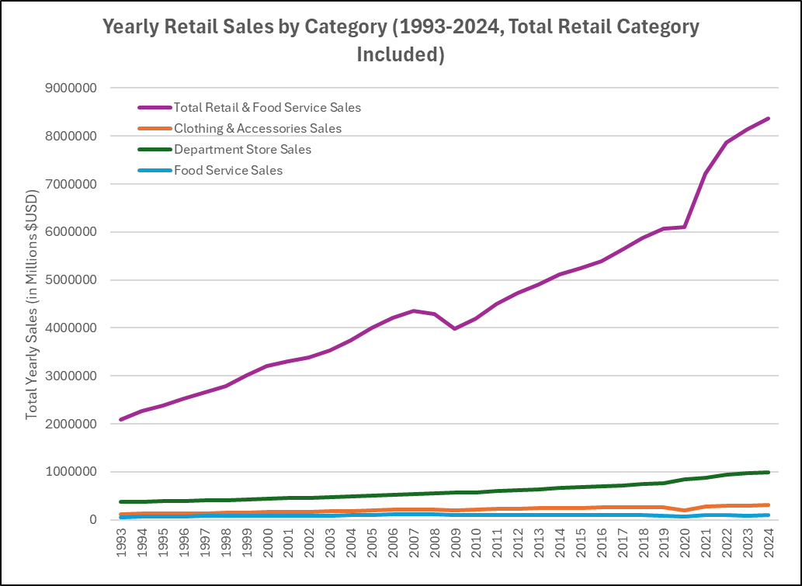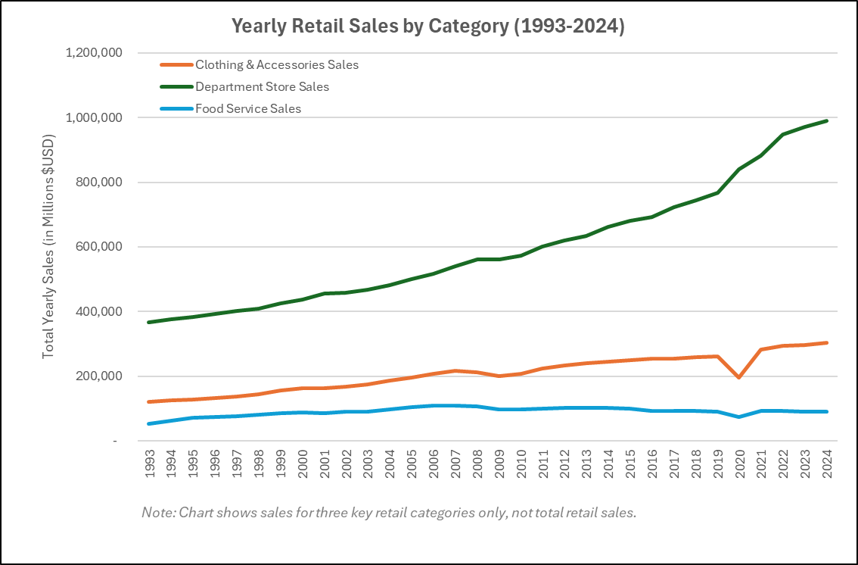

***Figure A.1:*** *Yearly Retail Sales by Category, Including Total Retail (Left) and Excluding Total Retail (Right)*

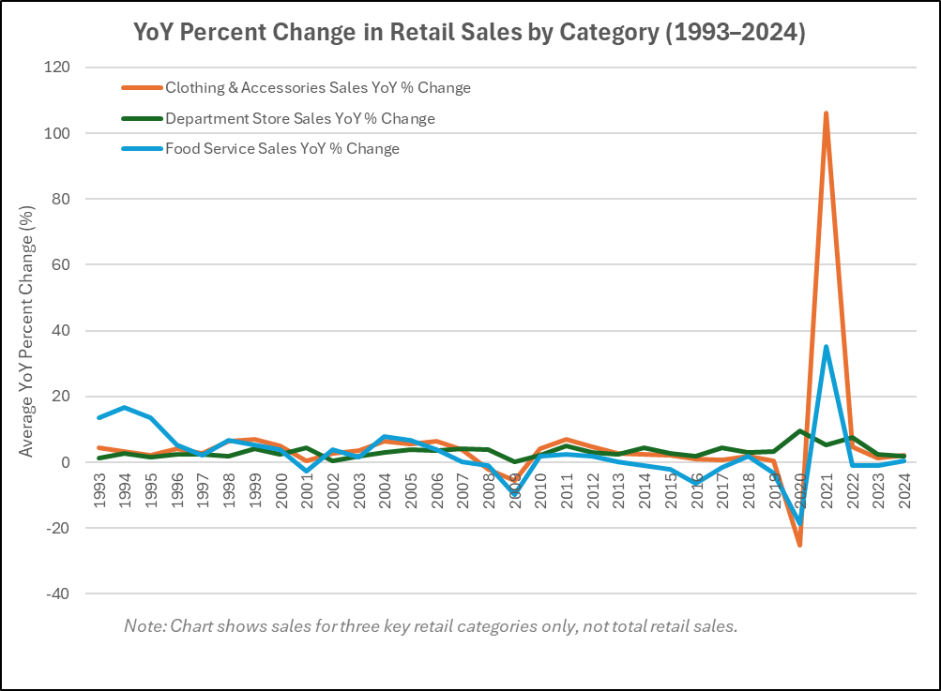

***Figure A.2:*** *Year-over-Year Percentage Change in Seasonally Adjusted Sales Across Retail Categories (1993-2024)*

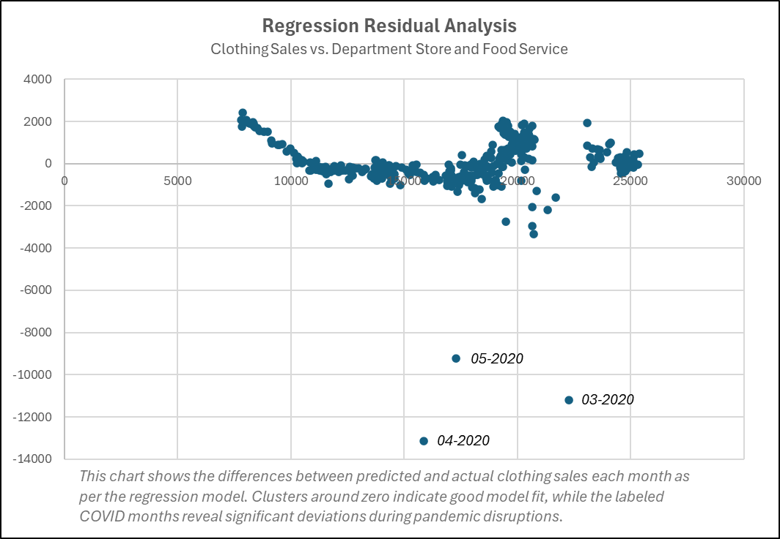

***Figure A.3:*** *Residual Plot for Clothing Regression Model (Showing Model Fit and Outliers)*